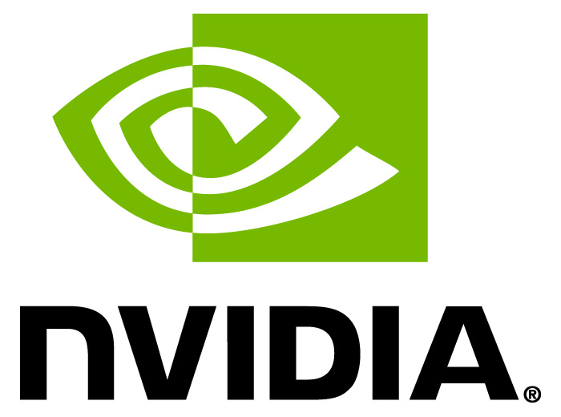
NVIDIA GLOBAL IMPACT AWARD
NOMINATION FORM

The NVIDIA Global Impact Award is a new annual grant of $150,000 that rewards innovative computing or visualization work targeted at the world’s most challenging social and humanitarian problems. The award will go to a researcher or institution that has used NVIDIA technology to achieve breakthrough results with positive social and humanitarian impact. This includes – but is not limited to – the areas of disease research, drug design & development, medical imaging, energy & fuel efficiency, climate modeling, weather prediction, natural disaster response, and cyber security.
Review Criteria
Nominees will be evaluated according to the following criteria:
- Innovation: Work supports new approaches or applies new insights in its field(s).
- Leverage: Results can be used by, or benefit, multiple researchers and motivate new innovations.
- Focus: Results focus on solving a specific problem.
- Impact: Innovation has a significant positive impact on a social or humanitarian problem.

Process and Timeline
Date | Activity
March 27, 2014 | NVIDIA Global Impact Award announced
Dec. 12, 2014 | Submissions due
March 13, 2015 | Finalists announced
April 28, 2015 | Award recipient named at GPU Technology Conference

NVIDIA Global Impact Award
Please return this completed form by Dec. 12, 2014, at 5pm PST. Questions and/or completed applications should be directed to Tonie Hansen, Director, NVIDIA Global Impact Award, globalimpact@nvidia.com. Applications should be sent as a Microsoft® Word or Adobe® PDF file.

Contact Information:
Nominator (if applicable)
Name
Institution
Email
Phone number
Nominee
Organization name
Contact name
Contact title/position
Contact email and phone number
Organization address
How did you learn about this opportunity? | Email from NVIDIA  NVIDIA GPU Technology Conference  Colleague/Friend (please include name and organization)______________________________________  Website (please specify)__________________________  Other (please specify)____________________________

Abstract:
Provide a high-level abstract of the work using language accessible to a layperson. The abstract should focus on the problem, and how the work and its results had an impact in the area of focus. (max. 100 words)
Details:
- Describe the field of the work as it applies to this award. What are the key problems in the field and how has visualization or computation been used previously (if it has) to address the problem? (max. 200 words)
- Describe the specific problem solved by the work. (max. 300 words)
- How did the work address this problem? How did the work advance the state of knowledge or practice in the field? How have the results been leveraged by others in the field or in a related area? (max. 400 words)
- How, specifically, were visualization or computational methods applied to the problem addressed by the work? (max. 400 words)
- How does the solution differ from other approaches to the problem? (max. 200 words)
- How was NVIDIA technology used in the work? (max. 400 words)
- How long did it take to complete the work? At what date was the work completed? (max. 100 words)
- Tell us about the experience and the skills of the team that completed the work. (max. 200 words)

Endorsement:
Each application may be accompanied by up to three endorsements. Each endorser should explain why they believe the project is worthy of recognition and identify any role played in the project. The endorsement should be provided as a letter in PDF format or as an email, and can be included with the application or sent separately to globalimpact@nvidia.com.
Each endorsement should include the following information:
- Name of endorser
- Title
- Institution/affiliation
- Email address/phone number
- Name of nominee
- Endorsement (up to 200 words)

